AI ASSISTED CODING
ASSIGNMENT - 9
NAME: P.SAI SHANKAR
HL-NO: 2303A52500 BATCH: 50
Lab 9.5:
Task-1 :
Prompt : # Generate a (a) Docstring, (b) Inline comments, (c) Google-style documentation for reversing a string function
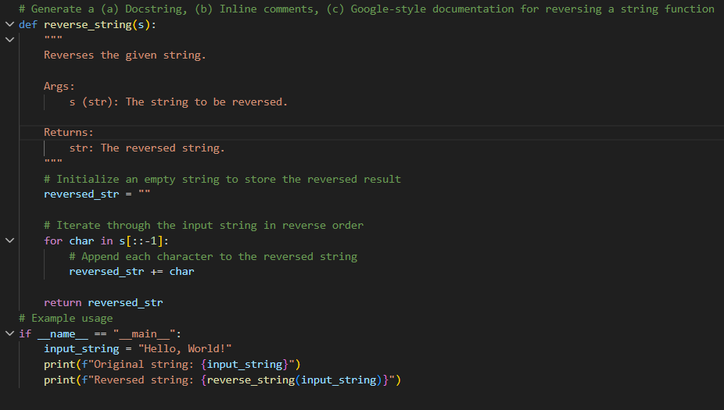
Output :
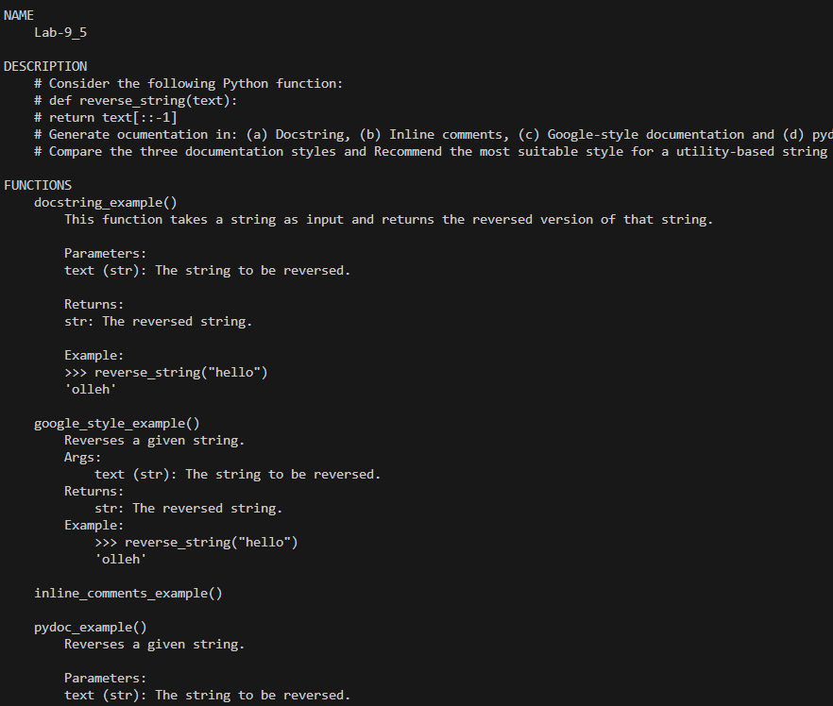
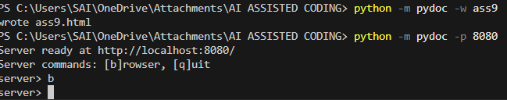
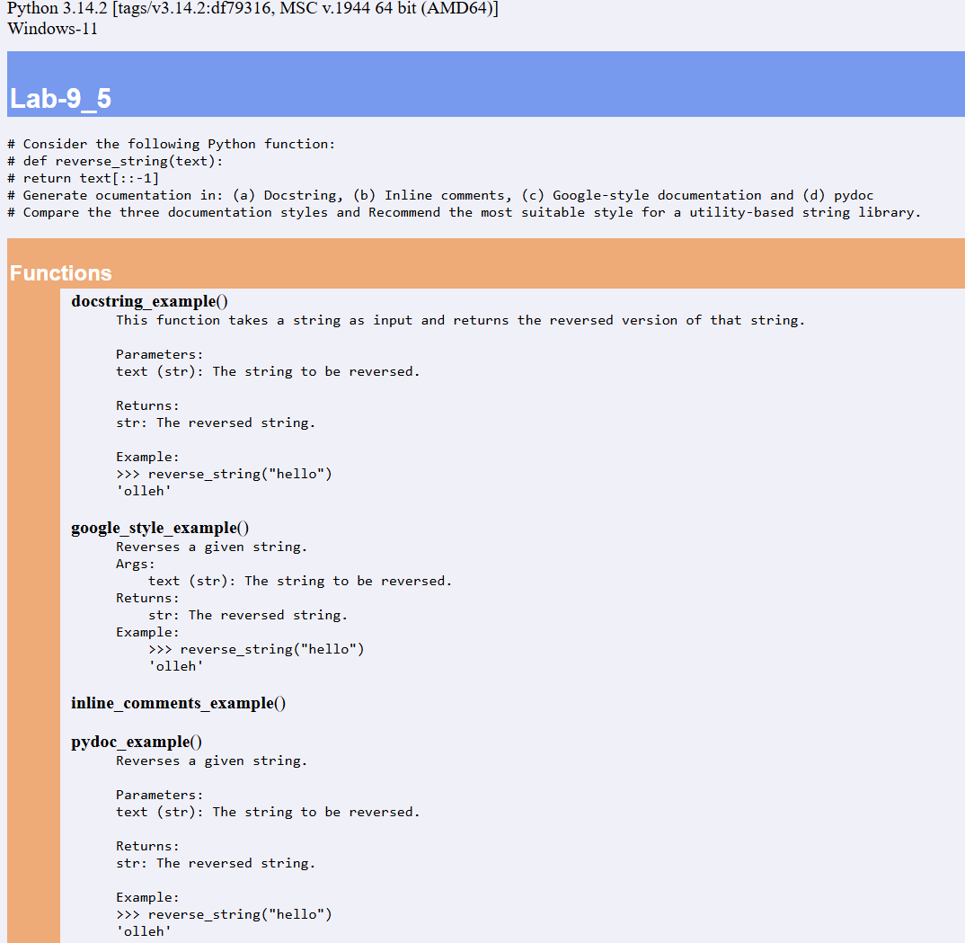

Task-2 :
Prompt : Generate a (a) Docstring, (b) Inline comments, (c) Google-style documentation for Password Strength Checker
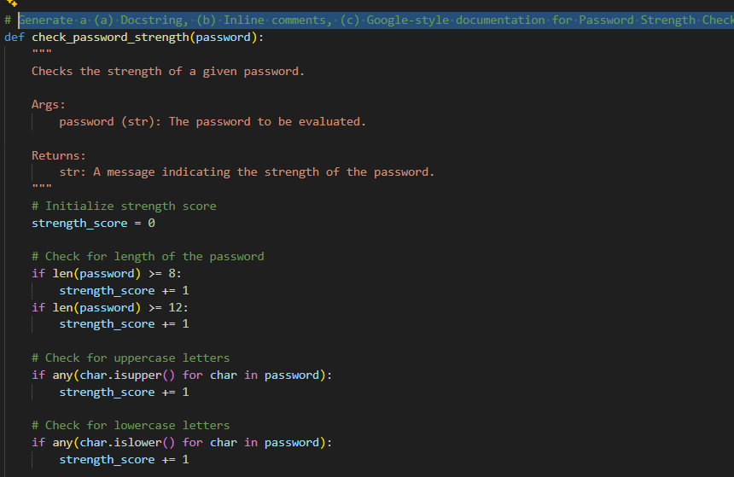
Output :
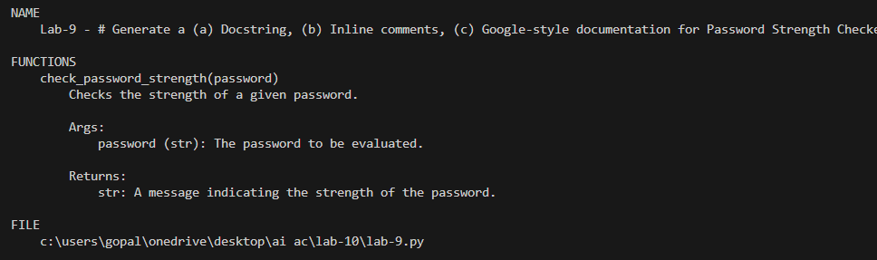
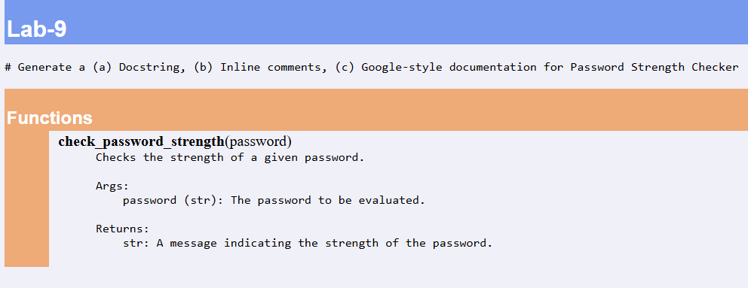

Task-3 :
Prompt : Generate a (a) Docstring, (b) Inline comments, (c) Google-style documentation for Math Utilities Module
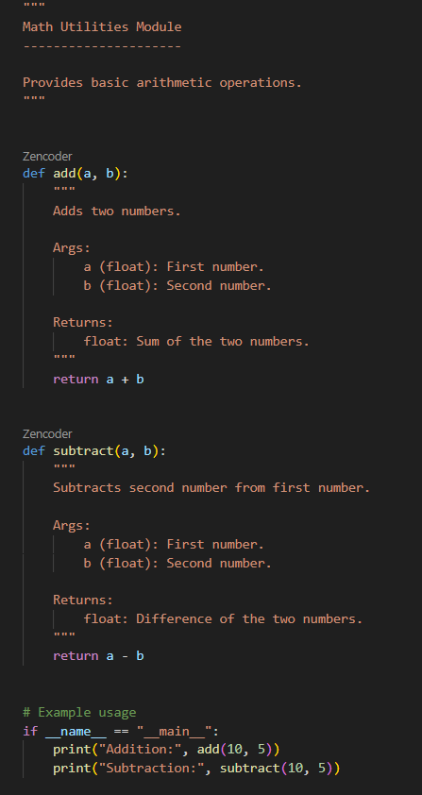
Output :
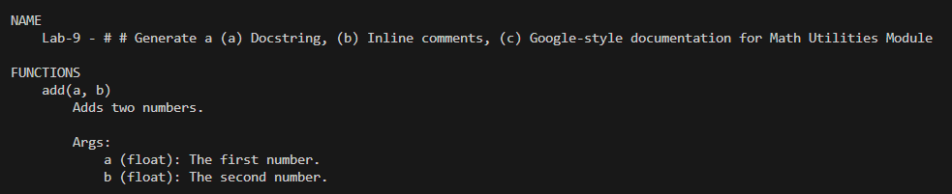
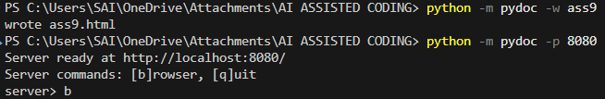
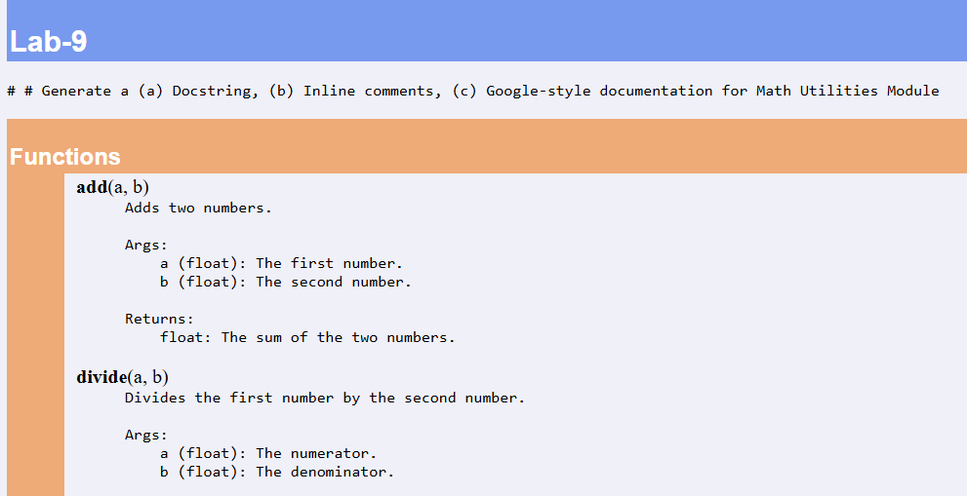
Task-4 :
Prompt : Generate a (a) Docstring, (b) Inline comments, (c) Google-style documentation for Attendance Management Module with only mark_presnt, mark_absent, get_attendence.
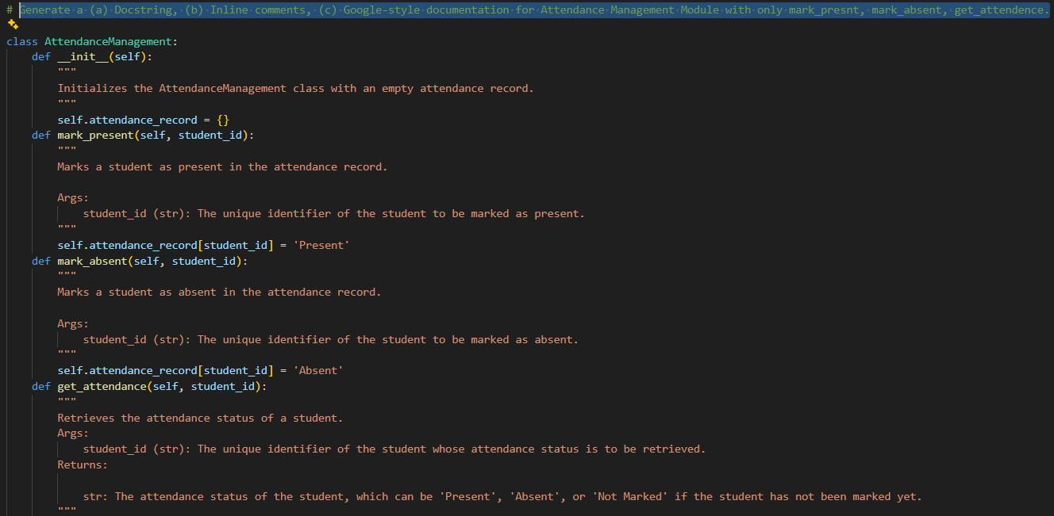
Output :
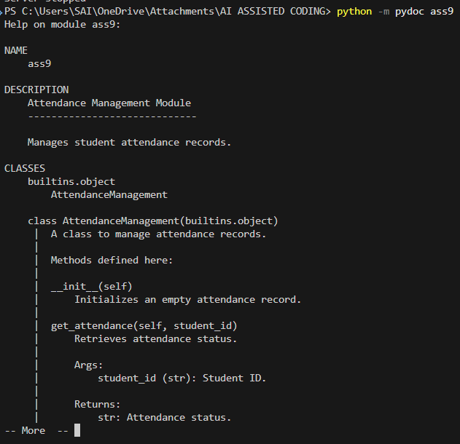
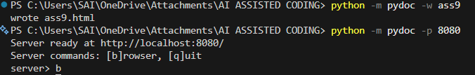
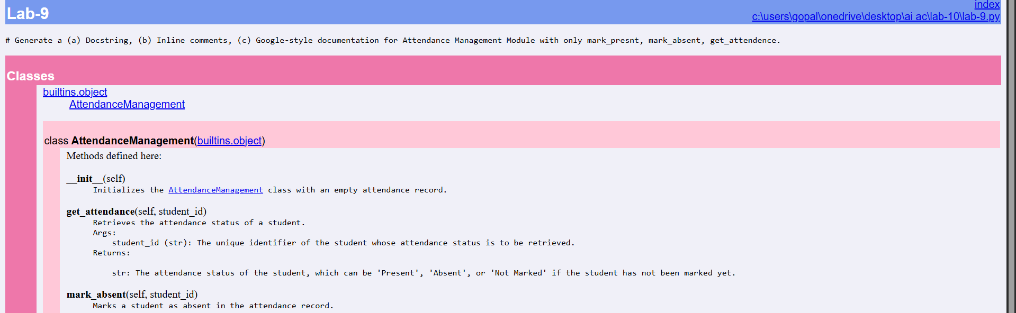
Task-5 :
Prompt : Generate a (a) Docstring, (b) Inline comments, (c) Google-style documentation for File Handling Function.
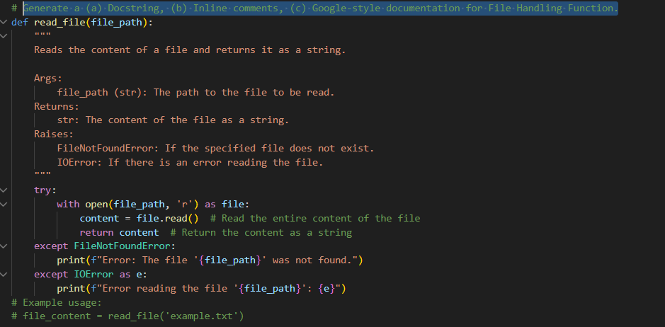
Output :
